Target System: Windows 11 IoT Enterprise (Sandbox Environment)
Date: June 2026

1. Executive Summary
This investigation simulates a critical security incident involving a threat actor establishing Persistence (MITRE ATT&CK T1543.003) via unauthorized Windows Service creation. Utilizing elevated privileges, the rogue components were identified, analyzed at the binary registry layer, and successfully remediated using native operating system utilities. This report details the detection and cleanup process.

2. Threat Simulation & Execution (Red Team Activity)
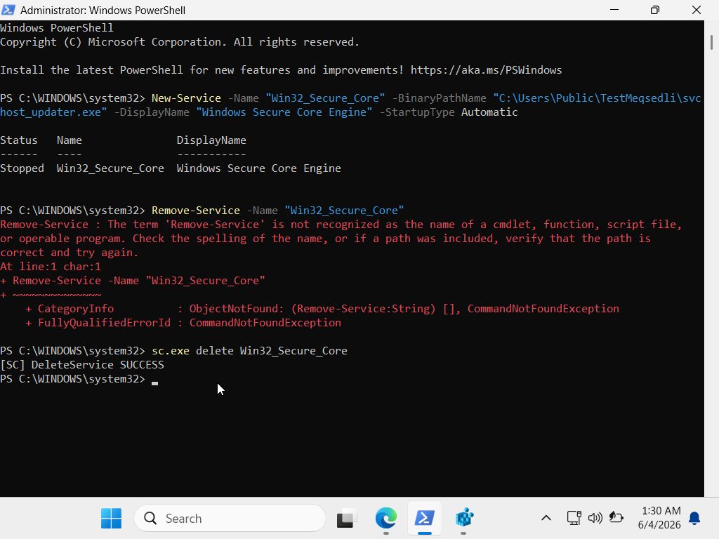
To model a real-world attack vector, a suspicious service was created using administrative PowerShell capabilities. The target binary (svchost_updater.exe, a masqueraded system process) was placed in a non-standard, low-privilege directory (C:\Users\Public\).
3. Forensic Detection & Registry Analysis (Blue Team Activity)
Windows stores all service configurations in a centralized binary database. As a security investigator, the registry hive was analyzed to gather forensic evidence of the persistence mechanism.
Registry Key Path: HKEY_LOCAL_MACHINE\SYSTEM\CurrentControlSet\Services\Win32_Secure_Core
Forensic Indicators Identified:
ImagePath Misalignment: The service path pointed to C:\Users\Public\... instead of the authorized C:\Windows\System32\ directory. This is a clear indicator of Masquerading (MITRE ATT&CK T1036).
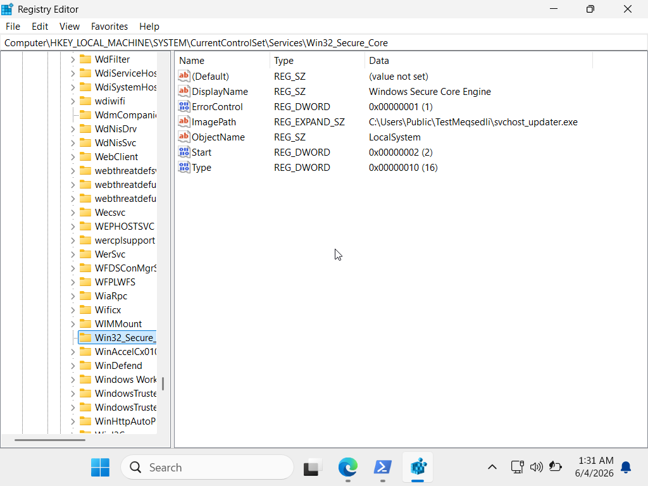
Start Value: The binary configuration value was set to 2, validating that the malicious service was programmed to trigger automatically during system boot.

4. Remediation & Countermeasures (Incident Cleanup)
To eliminate the threat and restore system integrity, a standard PowerShell cmdlet limitation was overcome by deploying the native Windows Service Controller utility (sc.exe). This forcefully purged the malicious service footprint from the HKLM hives. In screenshot one you can see the sc.exe delete Win32_Secure_Core command. With using this command we can remove the service from the system.

Artifact Analyzed: Windows ShellBags
Date: June 4, 2026
1. Executive Summary
During a simulated insider threat and data exfiltration investigation, the suspect was alleged to have accessed sensitive data and subsequently attempted to cover their tracks by performing a permanent deletion (Shift + Delete) of the target directory.

Standard file system inspection showed no traces of the directory on the Desktop. However, advanced registry forensic analysis was conducted on the ShellBags artifact (UsrClass.dat hive). The investigation successfully proved the historical existence of the deleted directory, reconstructed its original path, and extracted the exact creation and last access timestamps.

2. Threat Simulation & Anti-Forensics Attempt
To model the attack vector, a directory named analiz_2026 was created on the user's Desktop. To trigger the operating system's binary registry logging mechanism, folder view preferences were modified. The folder was then permanently purged from the file system to simulate anti-forensic evasion tactics.

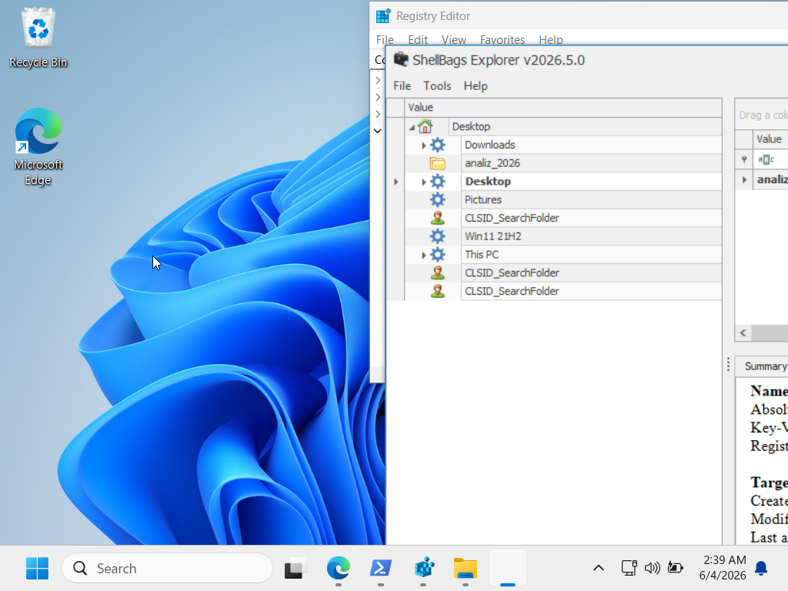
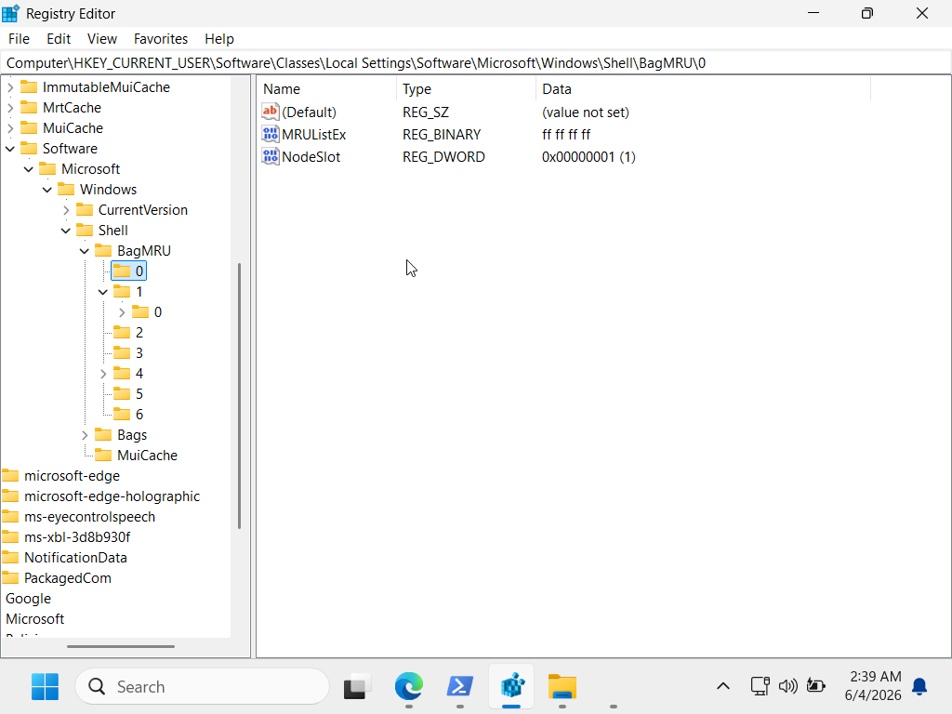
3. Forensic Extraction & Tool-Assisted Analysis
Because Windows natively stores ShellBags data as complex, nested binary structures within Shell\BagMRU and Shell\Bags keys, Eric Zimmerman’s rəsmi ShellBags Explorer utility was deployed to parse the hive.
The active registry was loaded into the parser, converting the low-level binary Shell Item ID List blocks into a human-readable folder hierarchy.
Forensic Findings:
Target Directory Name: analiz_2026
Absolute Path Identified: C:\Users\[User]\Desktop\analiz_2026
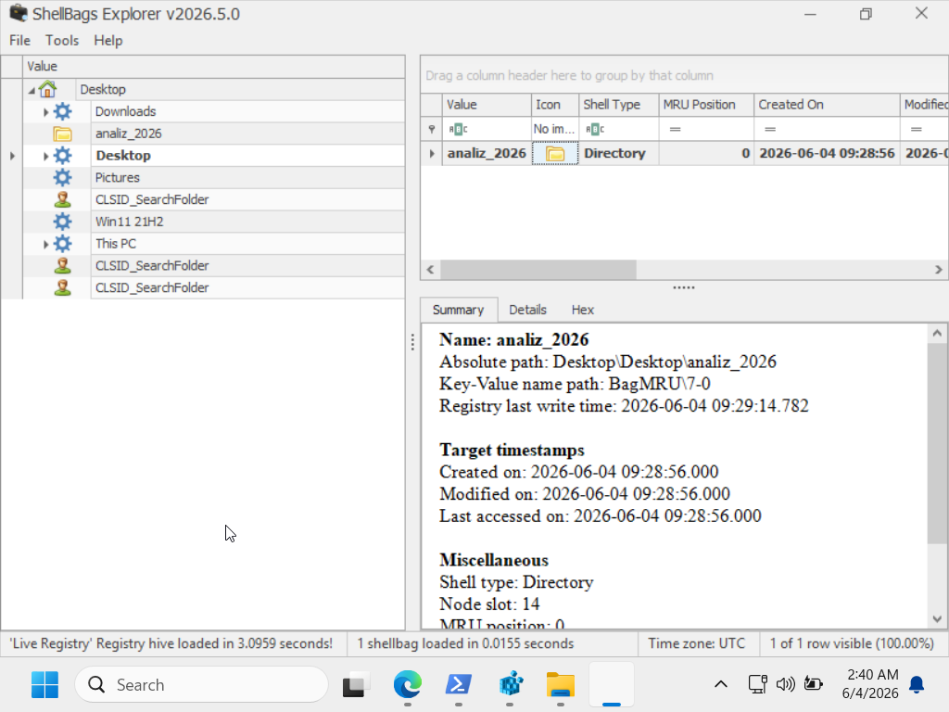
Temporal Evidence (Timestamps): Reconstructed exact execution times matching the investigative timeline (June 4, 2026).

4. Analytical Conclusion & Mitigation
The investigation conclusively demonstrates that the threat actor interacted with the analiz_2026 directory. The anti-forensic attempt to delete the folder failed to bypass Registry Forensics.
Recommendations for Enterprise Defense:
Registry Auditing: Implement active monitoring via SIEM or EDR systems for unauthorized exports or modifications of the HKCU\Software\Classes\Local Settings\Software\Microsoft\Windows\Shell path.
Volatile Memory Collection: In live incidents, perform memory dumps prior to system shutdown, as active shell extensions reside in RAM before being flushed to the disk hives.

